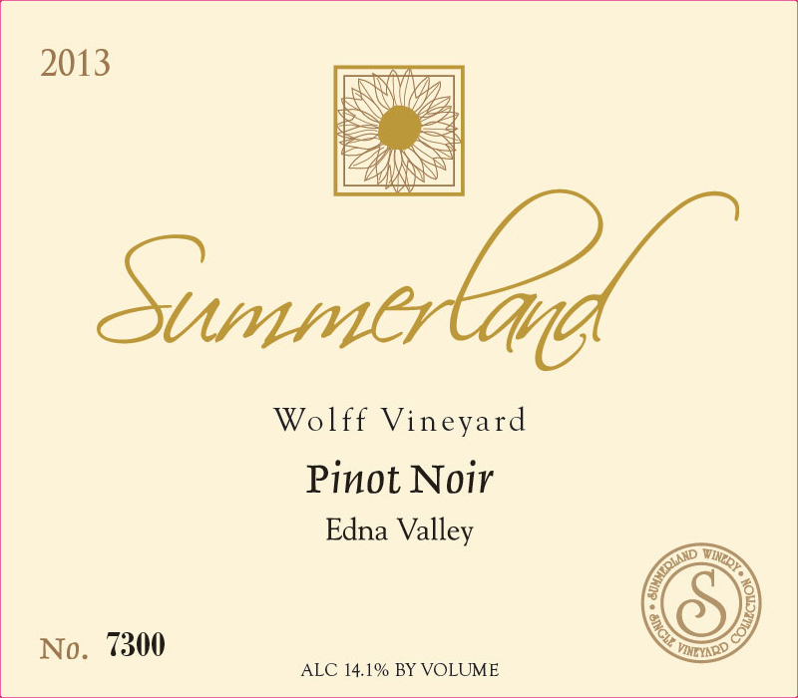 | 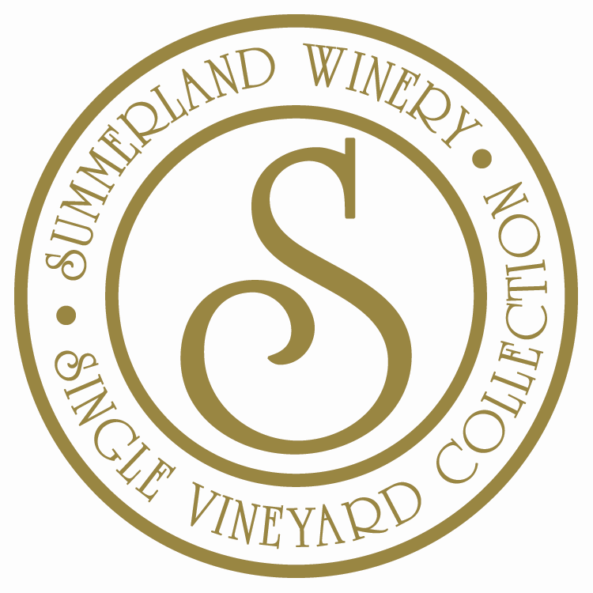  2014  PINOT NOIR  Wolff Vineyard  VINTAGE: 2014  VARIETAL: PINOT NOIR  APPELLATION: EDNA VALLEY  VINEYARDS: WOLFF VINEYARD  HARVEST DATE: 9/2014  BRIX AT HARVEST: 23.8  ALCOHOL: 14.1%  pH: 3.52  TA: 6.2 g/L  CASE PRODUCTION (9L): 230  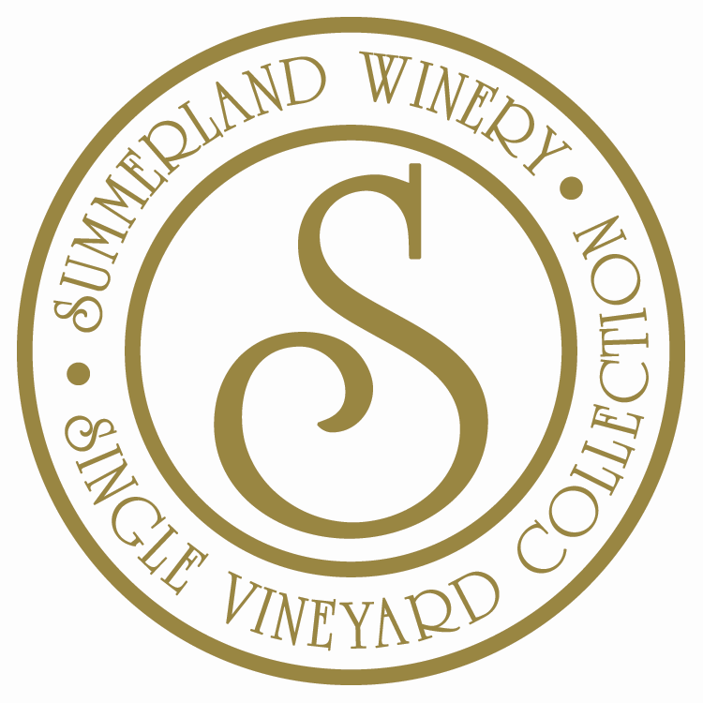CASE PACK: 12 X 750ML  RELEASE DATE: 8/2017  SUGGESTED RETAIL: $45.00
VINEYARD:
The Vineyard site was first planted over 35 years ago by one of the Edna Valley's winegrowing pioneers. The vineyard is impeccably farmed and biodynamic practices are deployed. The cooler climate of the Edna Valley and low yielding vineyards enjoyed at Wolff provide a flavor profile we find unique. Wolff Vineyards is one of the first vineyards in the Central Coast to become “Certified Sustainably Grown” as part of a pilot project with the Central Coast Vineyard Team. The vines are situated on steep slopes not common to the Edna Valley. Here the fruit benefits from southern exposure as well as from the shallow, well-drained sandy loam.
VINIFICATION:
The grapes were allowed to cold soak for a period of 6-7 days to extract color and flavor. The wine underwent fermentation in 1.5 ton open-top bins and was punched down by hand. Each Pinot Noir lot was inoculated with Assmanhausen yeast, known for its slow fermentation properties and organoleptic influence. The maceration period averaged 20-25 days for optimum tannin and color extraction. Aged for 11 months in 1/3 new oak in 100% Francois Freres cooperages from a variety of forests.
TASTING NOTES:
Our Summerland Wolff Vineyard Pinot Noir shows lovely depth, length and a style unique to Edna Valley AVA. An aromatic bouquet of oak and red fruit on the nose, gives way to hints of dried roses. A youthfulness is present , however, reveals itself on the palate, encompassing distinct flavors of bright raspberry, dried tobacco and exotic spice. A versatile pairing with food, it would do as well with a delicate dish of scallops and truffled risotto as with a more succulent duck dressed with fig sauce.

ACCOLADES:

